Eliot New, Hu Czernicki, Lucas Pawley, Dan Livermore

UOP COMPSCI  COMP2003

GROUP Z PROJECT PLAN: FaceIt online website overhaul

Contents

Initial Requirements -An Analysis Based on Client Requirements Gathering 2

User stories 2

Use Case Diagrams 3

Design Documentation 4

Research Documentation-Hosting Solutions 5

Commercial Hosting Solutions 6

Fasthosts 6

Charity Web hosting solutions 6

Plymouth University 7

Research Documentation – A CSS framework 7

Bootstrap 7

Bulma 7

Tailwind 8

Conclusion 8

Risk Management Plan 8

LEGAL, SOCIAL, ETHICAL & PROFESIONAL DOCUMENTATION 10

Legal 10

Social 10

Ethical 11

Professional 11

Project Vision

Group Z’s vision for the project is that we will design and produce a new website for the FaceIT charity. The website will function as a web page application that will be accessible from multiple platforms for many different types of users, whether they are on their laptop, mobile, tablet or desktop.

The new website will aim to preserve the content and functionality of the original one, whilst making minor adjustments or additions provided, they enhance the UX (user experience) or accessibility.

As the client is a charity, Group Z will approach this project with the goal of being as low cost and as low maintenance as possible, based on the initial meeting gathered requirements.

Project Vision- Product Designed for Independent maintenance.

Upon discussing the reality of hiring a software engineer to maintain and update the website, we propose that the website’s front and back-end design will designed to be as simple and accessible as possible. This will mean that, as the organization functions as a charity, volunteers interested in web development should be able to work on the website and collaborate provided they have some level of proficiency.

This would mean that the client may not need to pay for a software engineer to do every minor fix and update for content. It also provides an opportunity for students, professionals or retired software developers to be able to volunteer their time and skill for the cause of the charity.

Project Objectives

* Create a copy of the pre-existing website into a new CSS framework to improve the UI on mobile browsers.
* Produce suggestions and solutions to the hosting that is cheaper or tailored to registered charities.
* Create a codebase that is accessible for varying skill levels of web developers with a high standard of readability.
* Provide alternative methods of updating content on the website without the need of a web developer Particularly for updating news.

# Initial Requirements -An Analysis Based on Client Requirements Gathering

## User stories

User stories are a high-level way to help develop the requirements of a project. Below are several user stories created for the project scenario.

User

* As a user, I would like to access materials and complete quizzes and activities so that I can get the help I need.
* As a user, I would like the activities I complete on this website to only be accessed by the relevant users (healthcare professionals).
* As a user, I would like to be able to access the resources on my mobile device, so I can complete the sessions when I am away from my computer.

Healthcare Professional

* As a healthcare professional, I would like to add new users to the system without needing an administrator, so I can get my users quicker access to the helpful information.
* As a healthcare professional, I would like to be able to see what progress my users have made and have quick access to their answers.

Administrator

* As an admin, I would like to have full access to the details of every user of the website, so I can manage who has access to the system.
* As an admin, I would like to be able to remove users, so when they have finished using the system they can be removed for security and personal data reasons.
* As an admin, I would like to assign new healthcare professionals to the system so they can prepare their users to use the system
* As an admin, I would like to add new users to the system, so they can get started working on the materials.

## Use Case Diagrams

Expanding on the user stories, this diagram maps the user stories into a simple diagram to clearly demonstrate the functions of the intended application.

Figure 1- Use Case diagram

# Design Documentation

Now that user activities and functionality are established, we can map out the activities in the context of the software system. The sequence diagram shows the case of the user utilising the Activities and Journal services and it displays how our web app will then write and read from the database:

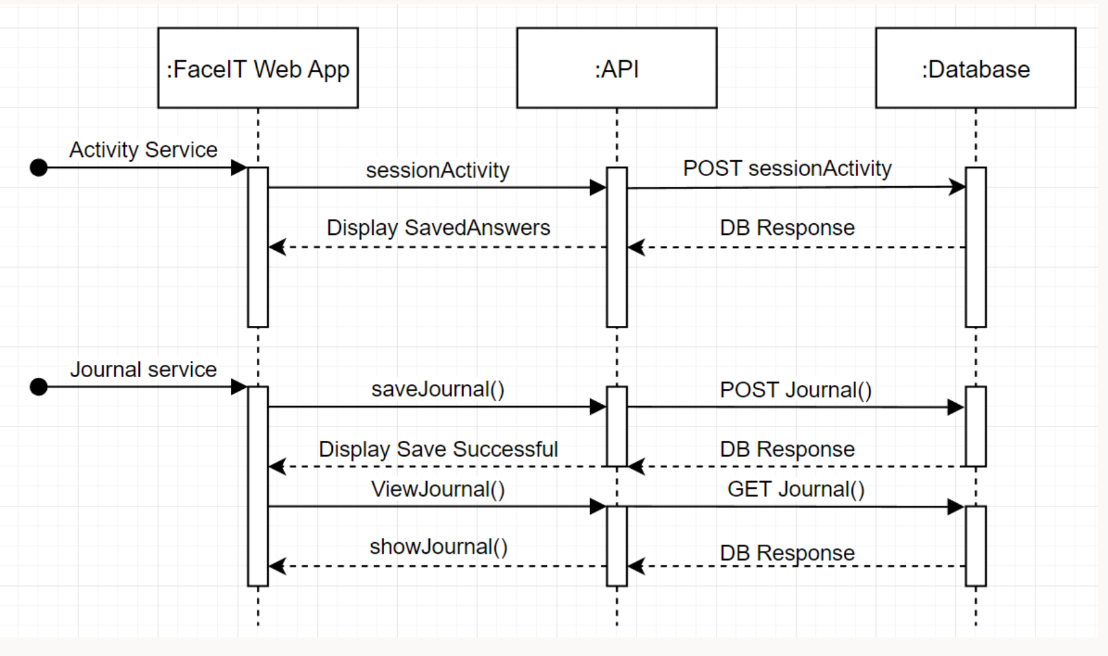

Figure 2- Sequence Diagram

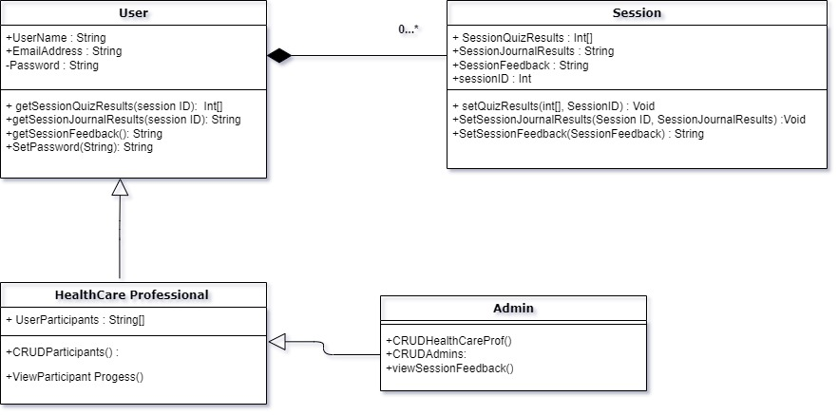

Figure 3- Class diagram

In figure 3 you can see that we have worked out the classes required for the application to work. The user class is a parent class with healthcare and admin forming a nested inheritance relationship to the class with extra features. Sessions exist as a 0 to many composition relationship to the user class.

# Research Documentation-Hosting Solutions

As we are offering alternative solutions for hosting the website, Group Z has investigated and received quotes on various hosting services as follows:

## Commercial Hosting Solutions

Fasthosts (<https://www.fasthosts.co.uk/web-hosting>)

Fasthosts’ web hosting packages offer 4 separate hosting solutions, at a variety of cheap prices. The package that we would be interested in is their ‘Ignite’ package. This package offers the hosting of 1 website with 10GB of storage, 2 1GB databases, and a free domain for 1 year. This package is £1 per month for the first 12 months then it is £5 per month afterward. This hosting solution allows us to have a website as well as a database for the login of the members of FaceIT.

Summary

* £1 per month (12 months) then £5 per month
* 10GB of Storage
* 2x 1GB databases
* Free Domain (1 Year)

Ionos (<https://www.ionos.co.uk/hosting/web-hosting>)

Ionos is a web hosting solution that offers 4 different packages, we are interested in their standard package. Their standard package is £2 (excl. VAT) for 6 months and then £5 (excl. VAT) afterward. Ionos offers 100GB of storage, which is hosted in 2 different datacentres for uninterrupted hosting even during maintenance and outages. As well as they provide 10 2GB databases for a total 20GB of storage for logins. Also, they provide a free domain and 24/7 customer support.

Summary

* £2 (excl. VAT) for 6 months then £5 (excl. VAT)
* 100GB of storage
* Hosted at 2 different datacentres for uninterrupted hosting
* 10x 2GB databases
* Free domain
* 24/7 customer support

## Charity Web hosting solutions

Kualo (<https://www.kualo.co.uk/free-charity-hosting>)

Kualo provide their solo plan free of charge and their other packages at a 50% discount. The solo plan is best for small websites, so using another package might be more suitable for the FaceIT website. The solo plan offers up to 10 email accounts, 5 databases and is also compatible with WordPress. The Kualo website builder is a drag and drop editor, so it can allow the FaceIT team to edit themselves rather than getting external help.

Summary

* Free hosting
* Website builder
* 10 email accounts
* Website builder
* 50% off other packages
* Must link back to the kualo website with a shoutout on a blog, if FaceIT has one

Krystal (<https://krystal.uk/charity-hosting>)

Krystal web hosting give free hosting to UK registered charities. Their free plan offers 10GB of storage, a free website builder, 20 databases, Unlimited email accounts as well as free standard backups. If the free web hosting package does not meet the requirements of the website, they offer 50% off their other packages. One draw back of the free package is that they ask that the website links back to the Krystal website.

Summary

* Free hosting
* Free Website builder
* 20 databases
* Unlimited email accounts
* Backup
* 50% off other packages
* Must link back to Krystal’s website

### Plymouth University

Awaiting response... Will update ASAP.

# Research Documentation – A CSS framework

## Bootstrap

https://getbootstrap.com

Positives

* Bootstrap is among the most popular open-source projects in existence.
* You can always find solutions to problems you run into.
* You can discover plenty of free and premium templates.
* It’s not solely a development framework, but also a pre-built dynamic template with countless ready-to-use components.
* This can make it easier for any developer, even without prior frontend experience, to develop well-structured pages.

Negatives

* Bootstrap comes with a very specific design and look, which is hard to override in case you’re going for a different style.
* Even though you can import parts of the project, it’s not as lightweight or modular as other frameworks.

Closing Thoughts

Bootstrap would be a good choice of CSS Framework as it is popular, this means that it should be easy to learn for people new to it. Additionally, Bootstrap has many pre-built and ready to use designs and components where there is not much technical skill necessary to take on updating or editing the site. This would allow any volunteer developers to take on a task of updating the page.

## Bulma

https://bulma.io

Positives

* It’s highly praised for its simple syntax and minimalistic but aesthetic design.
* It comes with a clean and modern design — even if you don’t change the defaults, you’ll end up with a great-looking webpage.
* Easy to create responsive layouts.
* Developer Friendly: Bulma comes with naming conventions that are easy to use and remember.
* Easy to customise: colours, paddings, and many default properties can be customized using SASS.

Negatives

* Since it’s quite distinct, if it gets overused, we can end up with very similar-looking websites, as is the case with Bootstrap.

Closing Thoughts

Bulma is a less popular CSS Framework to Bootstrap, however it offers a large array of customisation. It has the options to create and customise elements with responsive features which would allow good design across devices. Bulma also is very developer friendly allowing developers with less knowledge to still be able to understand and edit the page.

However, Bulma can cause websites to look very similar, especially more than Bootstrap which has the same issue. This could be an issue if the page is meant to stand out more than conform to a set look.

## Tailwind

https://tailwindui.com

Positives

* Tailwind makes all these common styles easy to implement by offering powerful utility classes.
* Even though Tailwind doesn’t include any pre-designed components, it allows you to create your own custom components that you can reuse throughout your projects.

Negatives

* Tailwind is not the best choice for less experienced developers.
* Tailwind’s learning curve is somewhat steep as you have to learn the syntax to be productive with the framework

Closing Thoughts

Although Tailwind doesn’t have any free pre-designed components or designs, it allows you to create your own components which can later be reused multiple times. This would mean that there is less time spent trying to make different components look similar as a new developer could reuse old the old templates. However, Tailwind has a rather steep learning curve, meaning that not everyone would be able to just pick it up and work on it.

## Conclusion

Even though we, as a group, have some experience with Bootstrap, I would propose using Bulma as it should be similar to Bootstrap while also being developer friendly to newer developers to pick up. By using Bulma I believe we can show that it should be easy to pick up and learn. Bulma also allows for clean and modern designs that would be the desired outcome of the webpage update, making a responsive and simple page with a modern design. Bulma also allows the developer to design across different devices meaning the webpage would be more accessible than the current counterpart.

# Risk Management Plan

In order to manage risks to the project , anticipating and planning risks will help us to reduce disruption to the project and its goal to meet the deadline.

Firstly we identified risks, then we assessed how disruptive they would be. Next we address how we will deal with them and what we can do to mitigate the risk.

Assessment of risk will be from the following scale:

Insignificant>Minor>Moderate>Major>Catastrophic.

* GitHub error/deletion
* Database Loss/Corruption
* General bugs
* Incompatibility with mobile browsers

Risk 1-GitHub Repository Corruption/Loss- CATASTROPHIC

In the event the project is lost or corrupted it would set back the entire operation to the beginning. Fortunately, there are things that can be done. GitHub has the ability to recover older versions and provided we still have code on our machines, we can always recover from them. To avoid it we must make sure that our repository is carefully managed and each team member carefully commits their work according to standard protocols. We can avoid it happening by ensuring that the Technical Lead (Dan) has enough knowledge to manage the repo correctly.

Risk 2- Database Loss/Corruption-MODERATE

Provided that we are using our own database and not working on Face/Its actual data this risk is only deemed at a moderate level. As the Data Protection Act will likely prevent us to view and handle the charities’ data. Any damage to our mock database will be relatively superficial. It would probably involve having to repopulate the tables etc but we can back up the code required to do so. It could be time consuming to fix but should be manageable. We can mitigate the likelihood of damage to the database by reviewing and testing our API and SQL codes with an emphasis of preserving data integrity.

Risk 3- General Bugs in the Code Base- MINOR

Debugging is a normal part of software engineering. We have allocated it as minor because it is unlikely bugs in the code will do much damage due to the nature of a web application’s code being modular for the most part. There is not much that can be done to mitigate bugs other than regular pushing to the repo and regular testing of changes. We can fix any issues by either rolling back the main branch or spending time identifying and fixing bugs.

Risk 4- Incompatibility with mobile Browsers- MODERATE

If the web application isn’t formatting on mobile browsers it would be adversarial to our goals to improve on the existing website. This would have a moderate effect in terms of workload because it will require starting again to reformat the website. Fortunately this is easily preventable by testing our CSS framework and formatting on mobile devices during the initial sprints.

Communication Plan

The purpose of our communication plan is to ensure that Dr. A Norman from FaceIt will be able to review and give feedback on design decisions and progress. This will enable us to collect feedback that will allow us to take an agile modeling approach to the development process. ( In layman’s terms allowing us to respond to change via collaboration and negotiation throughout the development process).

Dr. A Norman will act as a stakeholder during this process and regular communication will ensure that the project is steered towards her requirements. As she does not have a software background, it is vital that information presented to her is understandable without being too abstract or vague to allow for miscommunication.

Primarily communication will occur through the client liaison, Eliot New in the form of emails, zoom meetings or in-person meetings. The frequency of meetings will be variable as we expect to have Scrum product increments that may only produce less visual progress such as back-end functionality or improvements, which may not provide anything of interest for the stakeholder.

Post-Christmas break we anticipate that the progress of the development will occur at an increased pace and therefore we expect that Group Z will have more to offer for the stakeholder and as such, frequency of communication should happen after each sprint. If progress is only technical it may seem more appropriate that updates are in the form of emails rather than video meetings for the convenience of the stakeholder.

# LEGAL, SOCIAL, ETHICAL & PROFESIONAL DOCUMENTATION

## Legal

As the website has a database of logins for the users of the website, we must consider GDPR and the Data Protection Act (2018). The database for the website contains user’s personal information such as name and email address. Therefore, the database needs to compile with GDPR:

* Individuals must now be informed when their data is collected or processed.
* Individuals have the right to have all their data deleted from the records
* Individuals can ask for access to data and for information on why it is being processed

Also, to compile with GDPR, the user needs to give their consent when they are entering their data. The user must give clear and positive affirmation that consent has been given as well as:

* There must be positive opt-in boxes that do not pot out. Consent by implicit acceptance is not allowed
* Purpose of why data collected must be provided and only minimum data required to be collected.
* Data must be confidentially and securely stored, and it has an expiry date
* Data must be accurate and correct

As the service Face IT provides is a therapist charity, the website must enforce therapist and client confidentiality. Therefore, there will be security implemented into the database so that only the user’s therapist is able to access the answers to the quizzes. As we would like the user’s journal to be accessible by any device, the database will store the journals as well. Therefore, we don’t want anyone within the IT team to be able to access the journals as it is personal to the users, we will implement security so that only the users have permission to view the journals.

To conclude, as the database is storing personal information of users, we will follow GDPR as well as make sure that only users and the user’s therapist has access to the user’s personal answers to the quizzes as well as the user’s journal.

## Social

As this is an openly available website and service it is important that we have due regard for public health, privacy, security and the wellbeing of others and the environment. It is important that we do the best in our abilities to not discriminate against any groups and to allow equal access to the webpage to sectors in society – mental health professionals and clients – where possible.

We do this by following the ACM Code of Ethics and Professional Conduct; by contributing to society and to human well-being. As this is a service that provides a well-being helping aspect to people who struggle with their own visible differences, we are in turn able to contribute positively to society. By allowing use of such a well-being service, we also allow people to all experience the same opportunities as others, promoting the inclusion of all sectors of society.

We also must strive to make the service a fair and non-discriminatory service. By doing so we avoid harming people in both physical and mental ways, and furthermore we allow the service to allow equal opportunities to everyone. Thus, following both the BCS and the AMC by avoiding harm and conducting activities without discrimination on any grounds.  
  
To conclude, we must strive to create a service that allows equal opportunities to people without any discrimination and where it is also our responsibility to provide a safe and private service for people to use, contributing to their well-being.

## Ethical

Software engineers have an ethical duty to ensure technology is accessible to everyone while being accountable for the programs they develop, knowing the importance of what they are creating. Computing professionals must protect the user’s right to be anonymous to prevent threats to their physical and mental well-being and privacy. Enabling diversity is vital for this project as the website is focused on helping people with physical differences face social anxiety.

Developers should also be aware of the data that they handle when implementing code, as lots of the personal data is confidential. By respecting individuals' privacy and not accessing private information, they can, unless given explicit consent. Establishing policies for data collection and management should be in place, so only the bare minimum is recorded and stored anonymously, making this simpler to keep accurate and delete when there is no longer a need for this information. Along with this, software professionals must be confidential as they are entrusted with trade secrets and client data. If this information is misused, it violates laws in place to ensure that these concerns are upheld.

As this is our first project collaborating with other developers, it is important that we also respect their privacy and not access or tamper with their personal files. Otherwise, we would be breaking the laws put in place to protect everyone online, while we are meant to be making the internet a safer place for all users. This continues through our conduct with the rest of the development, respecting each other and the users of the system to use the best practices and influence the moral standards of the internet’s users.

In conclusion, we must strive to uphold the ethical standards of the industry, as keeping the client’s confidential information secure is vital to our roles as developers.

## Professional

It should be noted that as we are working with clients outside of the education organization that we have a duty to conduct ourselves professionally, during this module most of us are working directly for charities and businesses. As a result, consideration of LSEP implications is not to be ignored.

The BCS chartered institute for IT declares in its code of conduct a guide to professional approach named “Duty to the Profession” and lists each duty as:

1. *accept your personal duty to uphold the reputation of the profession and not take any action which could bring the profession into disrepute;*
2. *seek to improve professional standards through participation in their development, use and enforcement;*
3. *uphold the reputation and good standing of BCS, The Chartered Institute for IT;*
4. *act with integrity and respect in your professional relationships with all members of BCS and with members of other professions with whom you work in a professional capacity;*
5. *encourage and support fellow members in their professional development.*

Breaking down each guideline in order, first we must consider that we represent the profession itself. If we act in misconduct, we could affect future business opportunity for other software engineers and therefore the consequences of our actions could negatively affect others.

Secondly seeking to improve professional standards describes that the standards themselves could be subject to change and improvement, and where possible we should aim to excel and adapt methodology.

Thirdly, as members of the chartered institute, we are morally bound to represent the reputation by extension of it through our membership.

Fourthly we need to “act with integrity and respect” with all professional relationships. In this context it mostly applies to how we conduct ourselves with the client, Alyson from Face-It. Our client liaison (myself) will be dealing mostly with the client. Speaking personally as the client liason , professional conduct has been interpreted as:

* Writing formally and respectfully in emails and messages
* Addressing with respect as the client/stakeholder
* Making sure contact and meetings are not inconvenient
* Ensuring communication is consistent
* Keeping the work relationship strictly professional and not encroaching on personal and social topics without reason
* Delivering the product to a high standard in line with the client’s requirements in a timely manner.

Lastly to cover number 5 from the bcs code of conduct, to “encourage and support fellow members in their professional development”. This one is particularly relevant to our group as we are all student programmers with little experience compared to a standard industry professional. By ensuring that we each get a chance to have a go and learn from it, encouraging each other to participate and contribute we can ensure that individually we all personally develop and grow and use this group project to cultivate our skills.

To conclude, when considering professionality in our conduct, we must strive to be representatives and cultivate healthy positive relationships as we work.